
COMSATS UNIVERSITY ISLAMABAD

Name : Arafat Khan

Roll No : FA25-BDS-013

SUBMITTED TO: Mr. Khurram Iqbal

Date : 15 September 2025

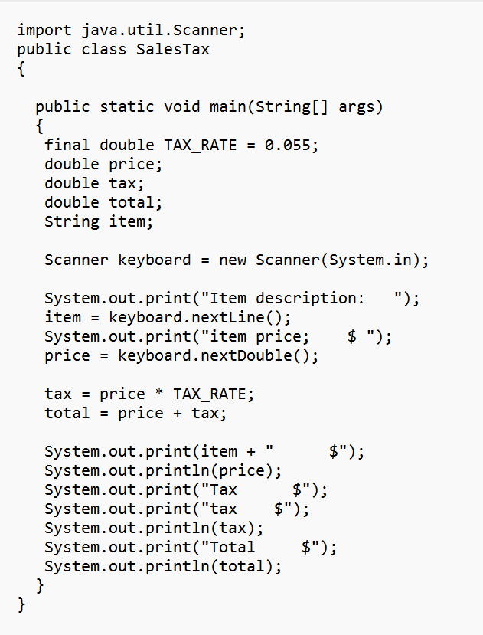
CODE FOR SALESTAX
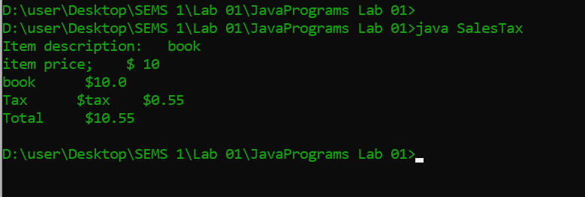
EXECUTING THE CODE
 |  | Tax Calculator Results
Item | Price | Tax | Total (calculated) | Total (Output)
Book | 10 | 0.55 | 10.55 | 10.55
Pen | 1 | 0.055 | 1.055 | 1.055
Pencil | 2 | 0.11 | 2.11 | 2.11
Marker | 3 | 0.165 | 3.165 | 3.165

